**HANDOUT 1**

**TM1637 7-SEGMENT DISPLAY**

**DESCRIPTION**

The TM1637 4-Digit 7-Segment Red Display Module incorporates four 0.36″ red 7-segment displays along with the TM1637 serial LED driver.

**PACKAGE INCLUDES:**

TM1637 4-Digit 7-Segment Red Display Module

**Module Connections**

* 1 x 4 Header
  + CLK =   Clock Input.  Connect to any digital pin on MCU.
  + DIO =   Data I/O.  Connect to any digital pin on MCU.
  + VCC =   3,3 or 5V to match MCU power.
  + GND =  Ground.  Must be common with MCU ground.

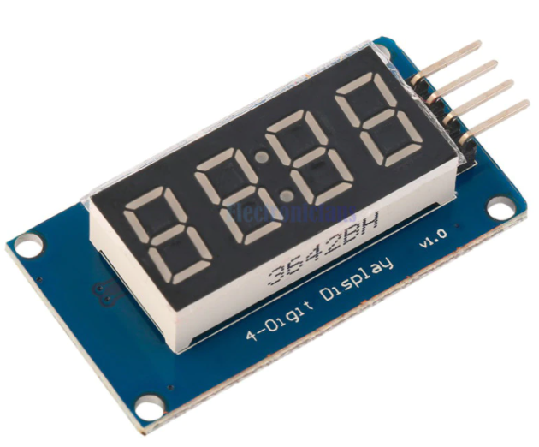

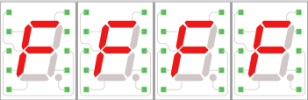

|  |  |  |  |
| --- | --- | --- | --- |
| **S1** | **S2** | **S3** | **S4** |

**TM1637 7-SEGMENT DISPLAY**

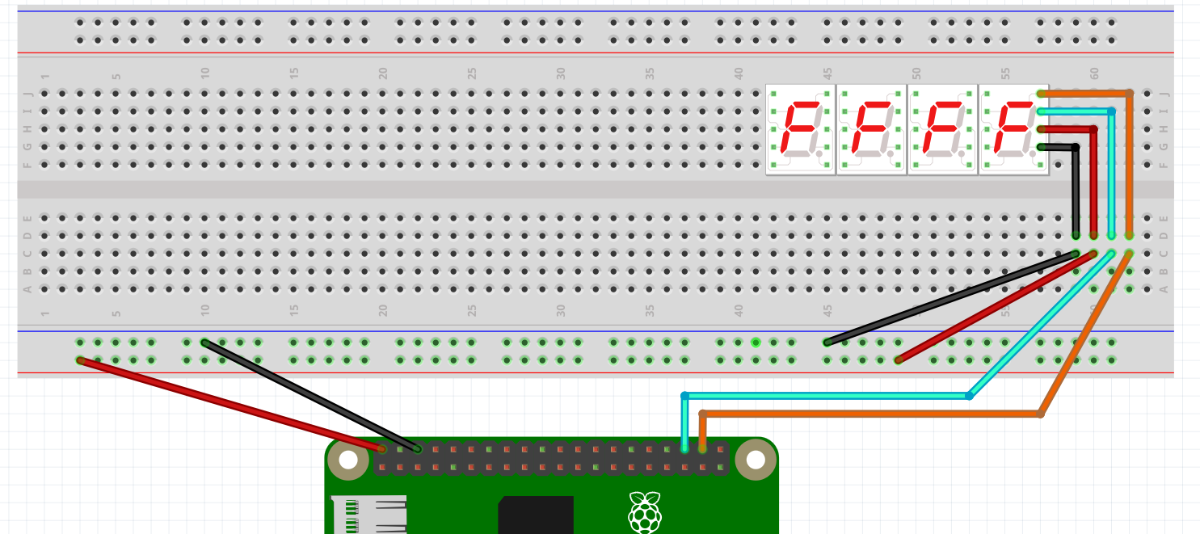

**CLK PIN 20**

**DIO PIN 16**

**DIO**

**CLK**

**VCC**

**GND**





**CLK**

**DIO**

**VCC**

**GND**

**CLK**

**DIO**

**VCC**

**GND**

**CLK**

**DIO**

**VCC**

**GND**

**CLK**

**DIO**

**VCC**

**GND**

**CLK**

**DIO**

**VCC**

**GND**

**CLK**

**DIO**

**VCC**

**GND**

**LET’S WIRE IT UP!!**